**Name :**

**Hafsa Waseem**

**Roll no:**

**SU92-BSSEM-S24-014**

**Subject :**

**DSA (Lab)**

**Section :**

**3A**

**Submitted to:**

**Sir Rasikh**

**Task no 1:**

**Create a program that declares an integer variable and a pointer to it. Modify the value of the variable using the pointer and display both the variable and pointer values.**

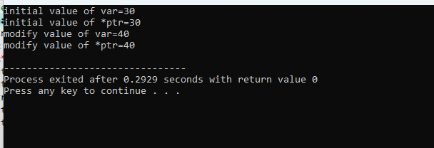

**Explanation :**

* We declare an int variable and initialize it to 20.
* We declare a pointer and assign it the address of variable using the unary & operator.
* We display the initial values of variable and pointer.
* We modify the value of variable using the pointer by assigning a new value to the memory location.
* We display the new values of pointer and variable .